Fiskur Með Ostur
Baked fish is a standard fare, but this dish adds a cheesy twist and is so easy to make.

Ingredients
6 fish fillets (cod or other type)
1 lemon
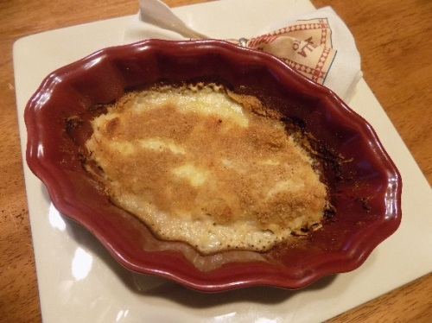
Salt and pepper to taste
1 cup grated Swiss cheese
1 tablespoon mustard
1 cup cream
1/2 cup bread crumbs

Instructions
- Preheat oven to 375°.
- Prepare a large baking dish by greasing bottom and sides with butter or use nonstick cooking spray.
- Place the fillets flat in a single layer in the prepared dish. Sprinkle with salt, pepper and freshly squeezed lemon juice.
- Cover with grated cheese.
- In a small bowl, combine the mustard with the cream and mix well. Pour over fish cheese layer.
- Sprinkle with bread crumbs.
- Bake for 35 minutes.

Alternatives & Substitutions
In place of the Swiss, make with any fondue-type cheese.
Serve with rice, noodles or mashed potatoes.
Yield 3-4 servings
Fiskur Með Ostur
Baked fish is a standard fare, but this dish adds a cheesy twist and is so easy to make.

Ingredients
6 fish fillets (cod or other type)
1 lemon
Salt and pepper to taste
1 cup grated Swiss cheese
1 tablespoon mustard
1 cup cream
1/2 cup bread crumbs

Instructions
- Preheat oven to 375°.
- Prepare a large baking dish by greasing bottom and sides with butter or use nonstick cooking spray.
- Place the fillets flat in a single layer in the prepared dish. Sprinkle with salt, pepper and freshly squeezed lemon juice.
- Cover with grated cheese.
- In a small bowl, combine the mustard with the cream and mix well. Pour over fish cheese layer.
- Sprinkle with bread crumbs.
- Bake for 35 minutes.

Alternatives & Substitutions
In place of the Swiss, make with any fondue-type cheese.
Serve with rice, noodles or mashed potatoes.
Yield 3-4 servings

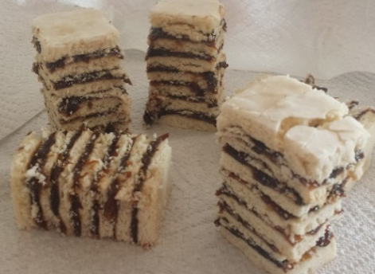
Vínarterta
A traditional 7-layer treat that is surprisingly easy and not too sweet. The perfect Icelandic treat to pair with coffee.
Ingredients
Filling
24 ounces pitted prunes* 1 teaspoon vanilla extract
1 tablespoon lemon juice 1/2 cup sugar
1 teaspoon ground cardamom 1/2 teaspoon cinnamon

Cookie Layer
1 cup butter, softened 4 cups flour
1 1/2 cup sugar 1/2 teaspoon ground cardamom
2 eggs 1 teaspoon baking powder
1/2 cup milk
1 teaspoon vanilla extract
1 tablespoon almond extract

Icing Glaze
1/2 cup powdered sugar
2 tablespoon water (adjust as needed)

Instructions
- Using a food processor, blend prunes to a thick paste. Place in a medium bowl. Add lemon juice, cardamom, vanilla, sugar and cinnamon, and mix well. Refrigerate until ready to assemble Vínarterta.
- In one large bowl, cream the butter and sugar together. Beat in eggs one at a time. In a smaller bowl, mix together the milk, vanilla extract and almond extract. In 3rd bowl, mix together the flour, cardamom and baking powder.
- Add a third of your dry ingredients to the creamed butter bowl and mix well. Then, add a third of the milk mixture to the butter bowl and mix well. Continue to alternate adding dry ingredients and wet ingredients to the butter bowl until everything is mixed together and batter is smooth.
- Divide dough into 7 small balls. Wrap in plastic wrap and refrigerate for 1 hour.
- Preheat oven to 350°. To prepare baking surface for seven layers, measure and cut parchment or baking sheets into seven 8”x 8” squares.
- Place one baking square on flat surface and tape to the work area. Lightly dust with powdered sugar (this will prevent sticking similar to flour but will not change the flavor). Place one dough ball in center and gently roll thin until dough covers entire surface just to edge. Remove tape from the paper and place the baking sheet directly on the cookie sheet or baking tray. Repeat with 2nd sheet and 2nd dough ball, continuing until all 7 are complete.
- Bake each layer for 10-12 minutes until firm, but not brown. Layers can be baked two at a time by placing them side by side on a single baking sheet. Transfer baking sheets to wire rack to cool completely.
- To assemble, warm prune filling to room temperature. Start with a cookie layer, cover completely with a generous, but not thick, layer of filling. Top with another cookie layer and cover with filling. Continue until all 7 layers are stacked. The top layer can be covered with a thin icing glaze.
- Cover cake in plastic wrap and store in a cool, dry place for at least 3 days prior to serving. Store up to 4 weeks.
Alternatives & Substitutions
* If using dried prunes (which are drier than pitted prunes), cook them with 1-2 cups water in large saucepan over medium heat until soft, before proceeding.
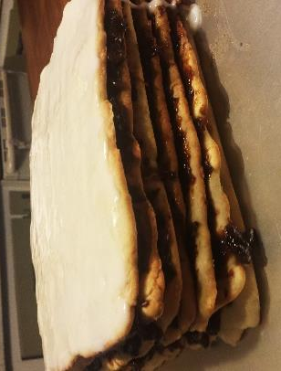
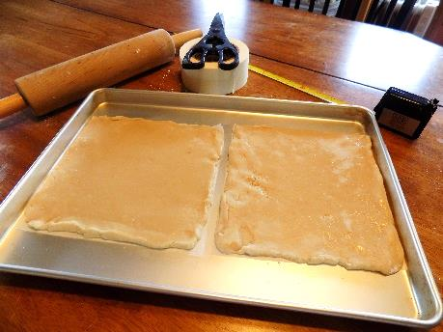
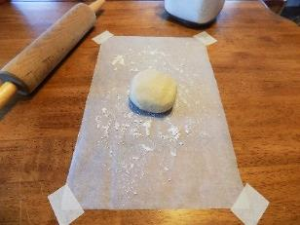
Process Photos

