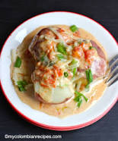
PAPAS CHORREADAS (POTATOES WITH CREAM AND CHEESE SAUCE)

Ingredients:

- 8 medium red potatoes, partially peeled
- Water
- 1 tablespoon vegetable oil
- 1 tablespoon butter
- 3 Scallions cut into 2 inch pieces
- 1 ½ cups diced tomatoes
- ¼ teaspoon garlic power
- ¼ teaspoon cumin
- ¼ teaspoon salt
- Pepper to taste
- 1 cup of heavy cream
- 1 tablespoon chopped cilantro
- 1 cup shredded mozzarella cheese

Preparation:
1. Place the potatoes in a medium saucepan. Cover with water, bring to boil, and cook about 30 minutes until tender. Drain and set aside.
2. While the potatoes are cooking, heat the oil and butter in a frying pan over medium heat. Add scallions and tomatoes, stir and cook about 7 minutes. Add garlic powder, cumin, salt and pepper. Stir and cook 2 minutes more.
3. Add cream, cilantro, and cheese. Mix well, turn down heat, and cook for 3 minutes or until cheese has melted.
4. Place the potatoes in a serving dish and pour the sauce on top. Serve hot.

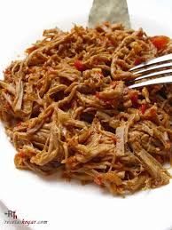
CARNE DESMECHADA O ROPA VIEJA (SHREDDED BEEF)
Ingredients:
- 2 Pounds flank steak
- 9 cups water
- 1 teaspoon salt
- ¼ teaspoon fresh ground pepper
- ½ cup hogao *
- 1 teaspoon tomato paste

Preparation:
1. In a pot, place the flank steak, water, salt and pepper. Cook over medium heat for about 1 hour and 15 minutes or until meat is cooked.
2. Measure 1 cup of the liquid used to cook the meat. Set aside.
3. Remove the beef from the pot, let it cool, and shred with a fork or your hands.
4. In a saucepan, place the shredded beef, hogao, tomato paste, and 1 cup of beef liquid. Cook for 6 to 8 minutes, stirring occasionally.
*HOGAO (Colombian Creole Sauce)  Ingredients :  - 3 tablespoons vegetable oil  - 2 cups fresh chopped tomatoes  - 1 cup chopped scallions  - 1 clove garlic, minced  - 1 teaspoon ground cumin  - ¼ teaspoon salt  - ¼ teaspoon ground pepper | Preparation:  1. Heat the oil in a saucepan. Add the tomatoes, scallions, garlic, and ground cumin, and cook gently for 10 minutes, stirring until softened.  2. Reduce the heat to low, add the salt and, cook for about 10 minutes more, stirring occasionally until the sauce has thickened. Check and adjust seasoning.
5. Serve hot over white rice.
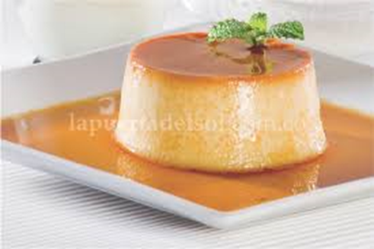
POSTRE DE LAS TRES LECHES (THREE MILKS DESSERT)
Ingredients:
- 1 Can of Condensed milk (14 OZ)
- 1 Measurement of Heavy cream (equal volume to condensed milk)
- 1 Equal part of whole Milk (2% is fine)
- 4 Eggs
- 1 tbsp of vanilla extract.

Preparation:
1. Pre- heat the oven to 350˚ F
2. Put all of the ingredients on the blender and mix them until all of the ingredients are included. All liquids are equal parts and can be measured by using the can from condensed milk.
3. Grease 8” square Pyrex baking dish or cake pan with butter and pour in the mix. Bake for approximately 40 to 45 minutes or until a toothpick stuck in the middle comes out clean.
4. Remove from the oven onto a safe surface and leave to cool before serving
Note: You can shave lime zest to top for an extra zing.

LIMONADA DE COCO (COCONUT LIMEADE)
Ingredients:
- 1 cup cream of coconut
- 2 ½ cups crushed iced
- Juice of 3 limes
- 2 tablespoons of sugar or to your taste

Preparation:
1. Place all the ingredients in a blender until smooth.
2. Serve immediately and enjoy.

